NOS Report

- Student: Issam Awamleh
- Company: JODDB(Cyber shield)
- URN of NOS: TECIS609301
- Name of NOS: Contribute to routine threat intelligence tasks

**Performance criteria of the NOS and how you applied it in your company **
(Explain and include evidence from your work)
Performance Criteria Evidence
P1: Use defined external threat intelligence sources to collect data
My Dark Web Project:
I collected intelligence from external threat sources like TOR markets, leak forums, breach databases, and paste sites. My main job was monitoring for specific organizational keywords and domains to see if any data had been leaked. I searched for compromised credentials, employee emails, and sensitive information being sold on the dark web, then extracted useful indicators like email addresses, domains, and file hashes.
Evidence: I actively scanned the dark web to catch if company assets were exposed or being traded in underground markets.
Dark Web Leak Site :

Darknet Army http://darknet77vonbqeatfsnawm5jtnoci5z22mxay6cizmoucgmz52mwyad.onion
Submarine http://no6m4wzdexe3auiupv2zwif7rm6qwxcyhslkcnzisxgeiw6pvjsgafad.onion
Everest Group http://ransomocmou6mnbquqz44ewosbkjk3o5qjsl3orawojexfook2j7esad.onion
CRYP70N1C0D3 http://7k4yyskpz3rxq5nyokf6ztbpywzbjtdfanweup3skctcxopmt7tq7eid.onion
CL0P^_- LEAKS http://santat7kpllt6iyvqbr7q4amdv6dzrh6paatvyrzl7ry3zm72zigf4ad.onion/
RansomEXX v2 http://rnsm777cdsjrsdlbs4v5qoeppu3px6sb2igmh53jzrx7ipcrbjz5b2ad.onion/
Bit Cards http://nalr2uqsave7y2r235am5jsfiklfjh5h4jc5nztu3rzvmhklwt5j6kid.onion/list.html
Svoboda http://svoboda7s2yird3p643lzbl7d6yc3rcciowopcxclqw6fsq26vmqruyd.onion
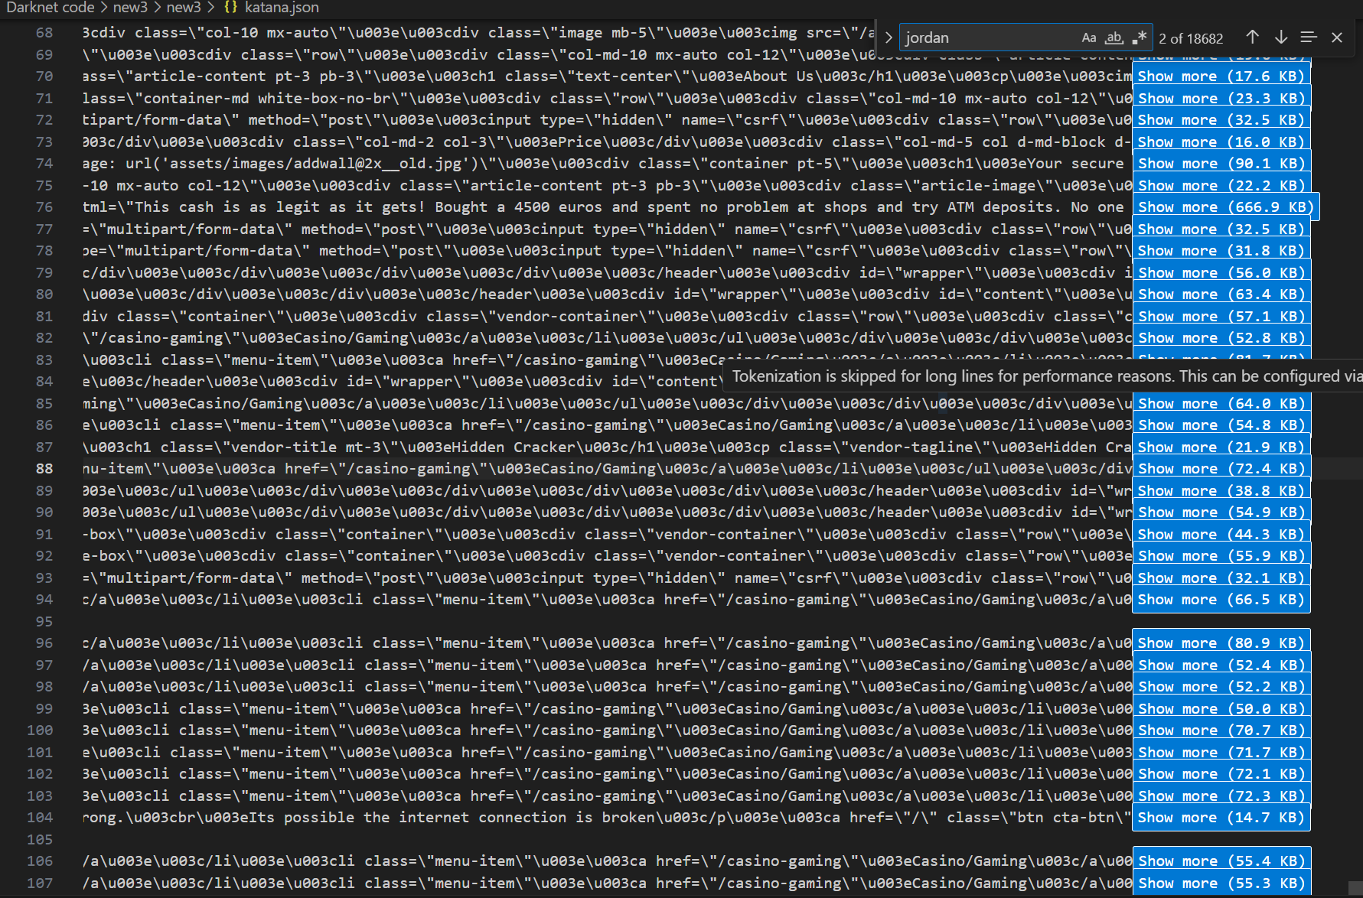

P2: Carry out threat hunting within internal networks
My SOC Work (CTF Tournament):
During the CTF, I hunted for threats using SIEM logs and network monitoring. I triaged alerts from IDS/IPS systems, dug through logs looking for suspicious patterns, and tracked potential lateral movement or unauthorized access attempts.
Connecting both projects: When I found leaked credentials on the dark web, I could cross-reference them in the SIEM to check if attackers were trying to use them in credential-stuffing attacks.
Evidence: My SOC work involved hands-on threat hunting through live security monitoring and incident investigation.
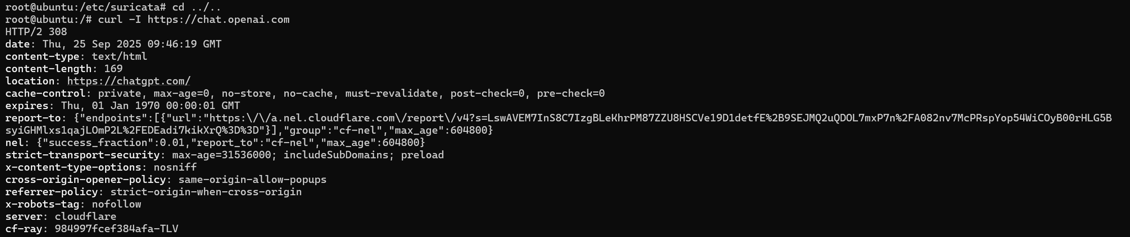
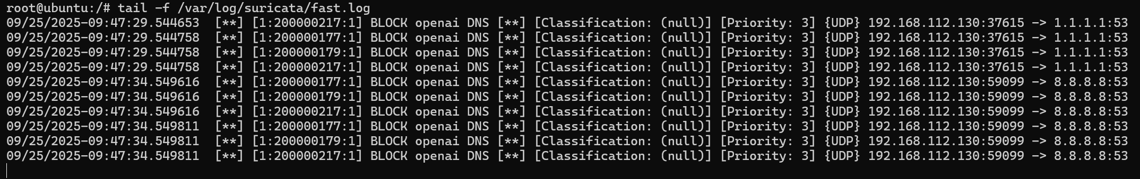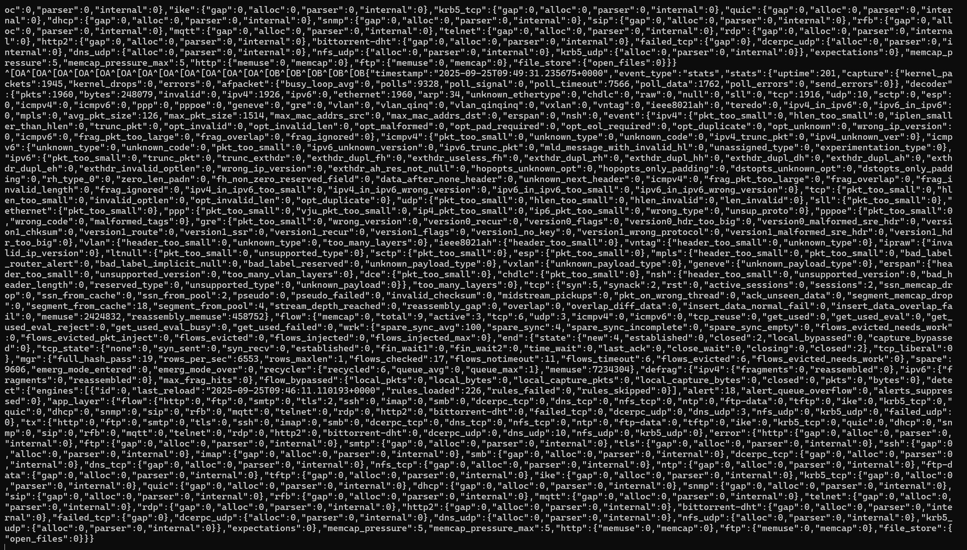

P3: Develop threat assessments using threat intelligence workflows
My Dark Web TI Workflow:
I followed the complete intelligence cycle:
- Requirements: Figured out what to monitor (company domains, keywords, email patterns)
- Collection: Gathered data from TOR sites, forums, breach dumps
- Processing: Sorted through findings, filtered noise, organized the good stuff
- Analysis: Assessed how bad the leaked data was and what attackers could do with it
- Reporting: Delivered findings with clear recommendations
Evidence: I worked through the full TI lifecycle from start to finish, not just collecting data but actually making sense of it.

P4: Identify threats to information systems, networks and data
From My Dark Web Project:
- Leaked employee credentials floating around
- Company domains mentioned in fraud schemes
- Stolen data being sold that could enable credential stuffing or phishing
- Exposed API keys or internal documents
From My SOC/CTF Work:
- Network-based attacks (port scans, brute force attempts)
- Malware infections and C2 communications
- Lateral movement indicators
- Data exfiltration attempts
Evidence: Between both projects, I identified threats from the outside (dark web intelligence) and inside (network monitoring).
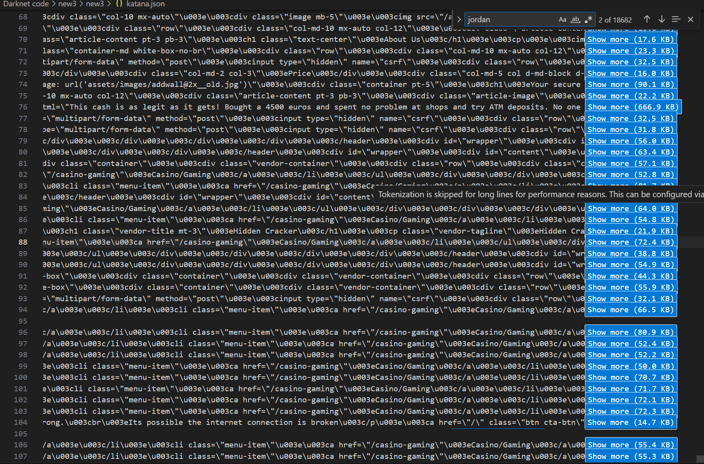
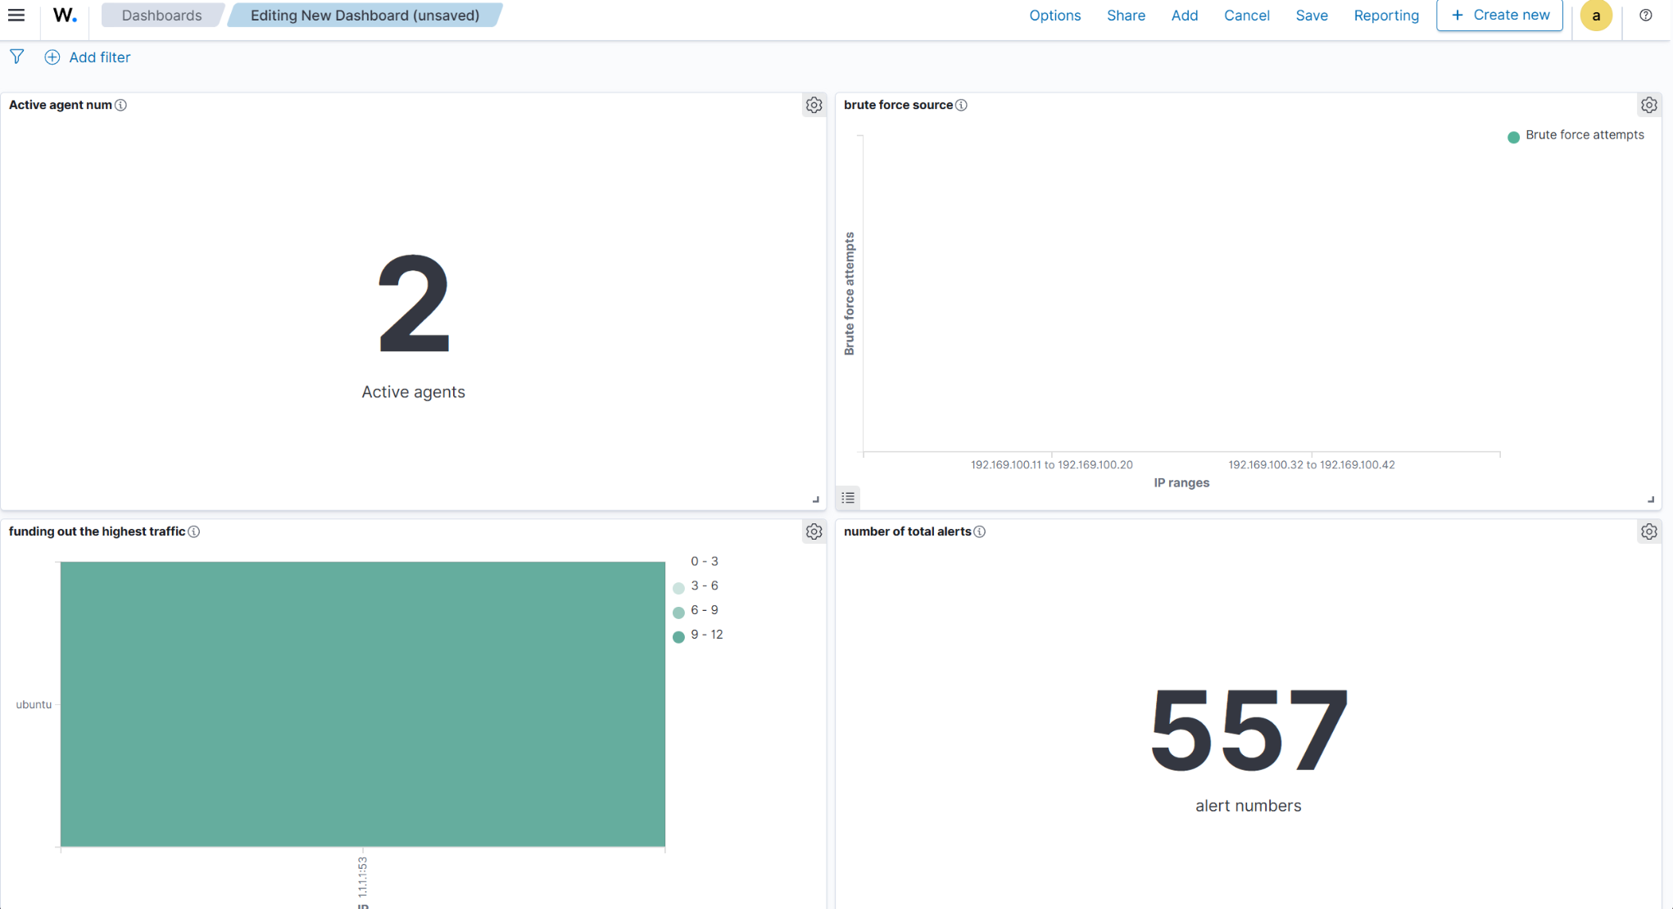

P5: Respond to requests for threat information in required timescales
Dark Web Side:
When I discovered leaked organizational data, I reported it immediately. Stakeholders needed to know fast so they could reset passwords or take action.
SOC Side:
During CTF, I responded to incident alerts and investigation requests within the competition timeframes. When something looked suspicious, I escalated it quickly.
Evidence: I delivered findings on time in both projects—whether it was dark web alerts or CTF incident reports.
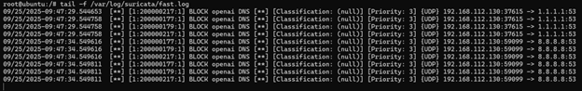
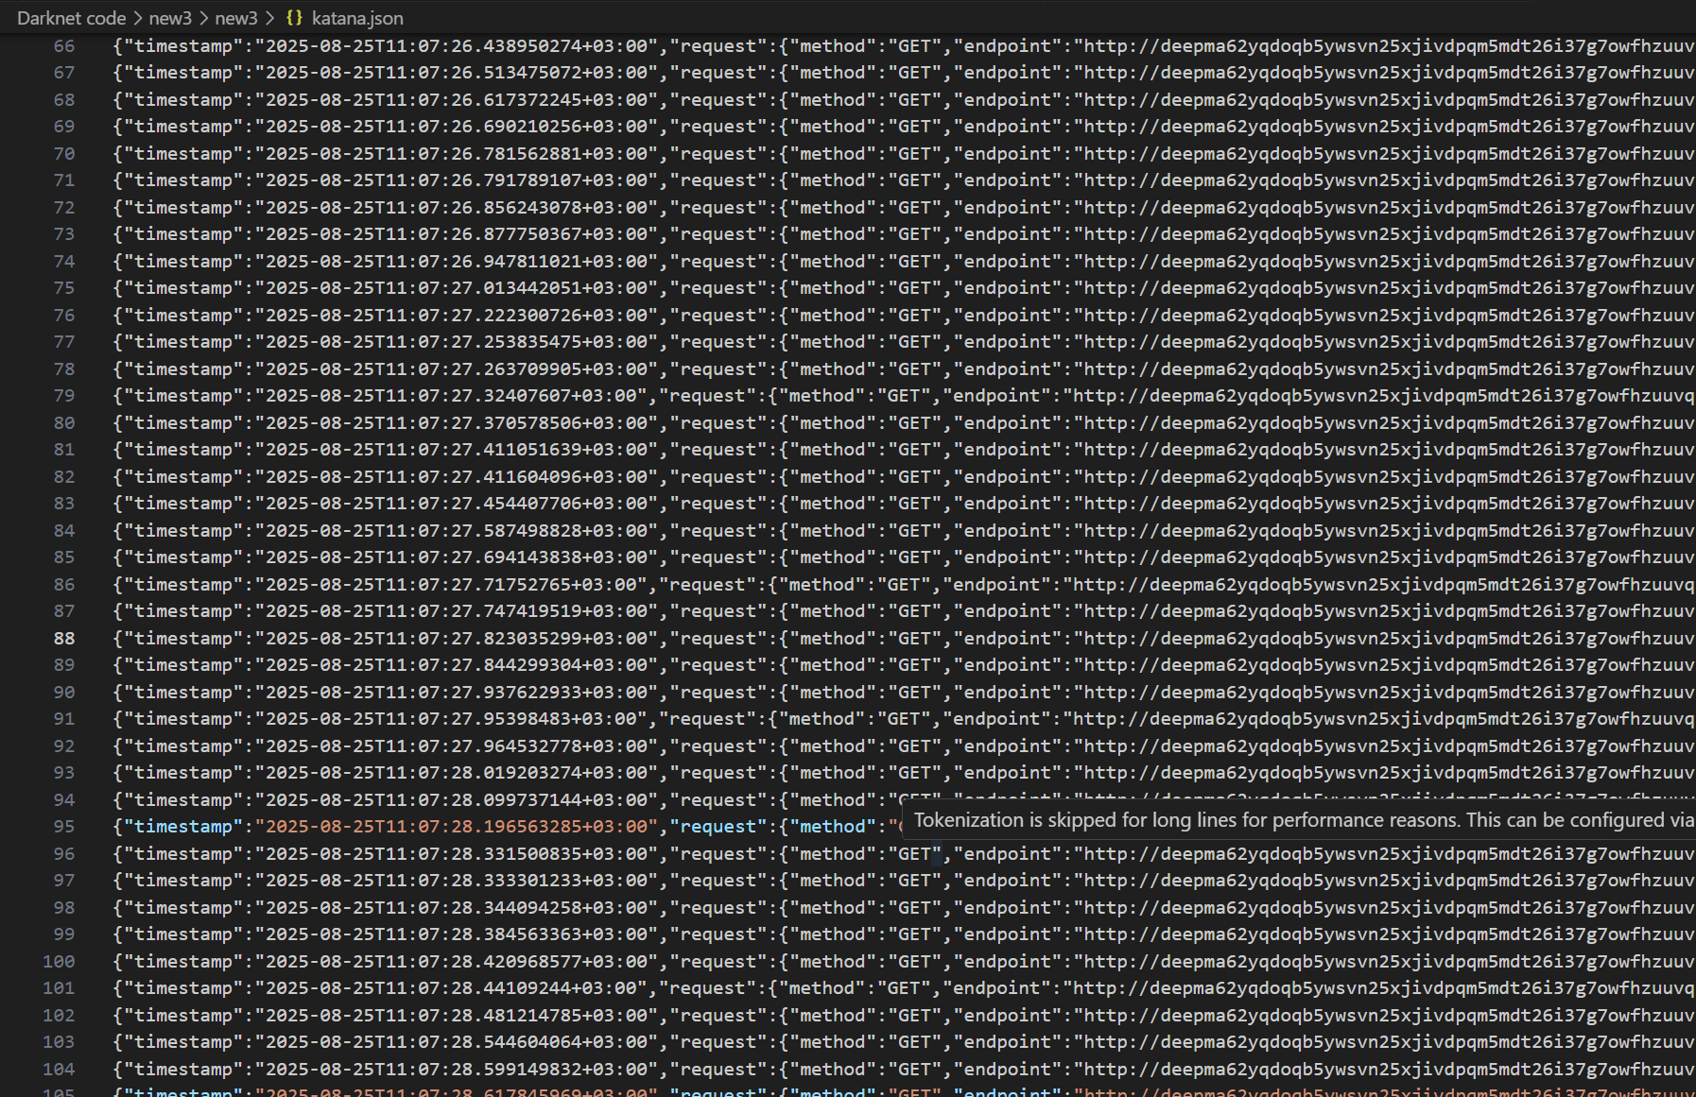

P6: Perform packet capture analysis to identify threats
My SOC/CTF Work:
I used Wireshark and network monitoring tools to analyze packet captures. This helped me spot things like:
- Suspicious traffic patterns
- Command and control communications
- Data being exfiltrated
- Attack signatures in network traffic
Evidence: Packet analysis was a core part of my SOC work during the CTF—I had to dig into network traffic to find what was really going on.
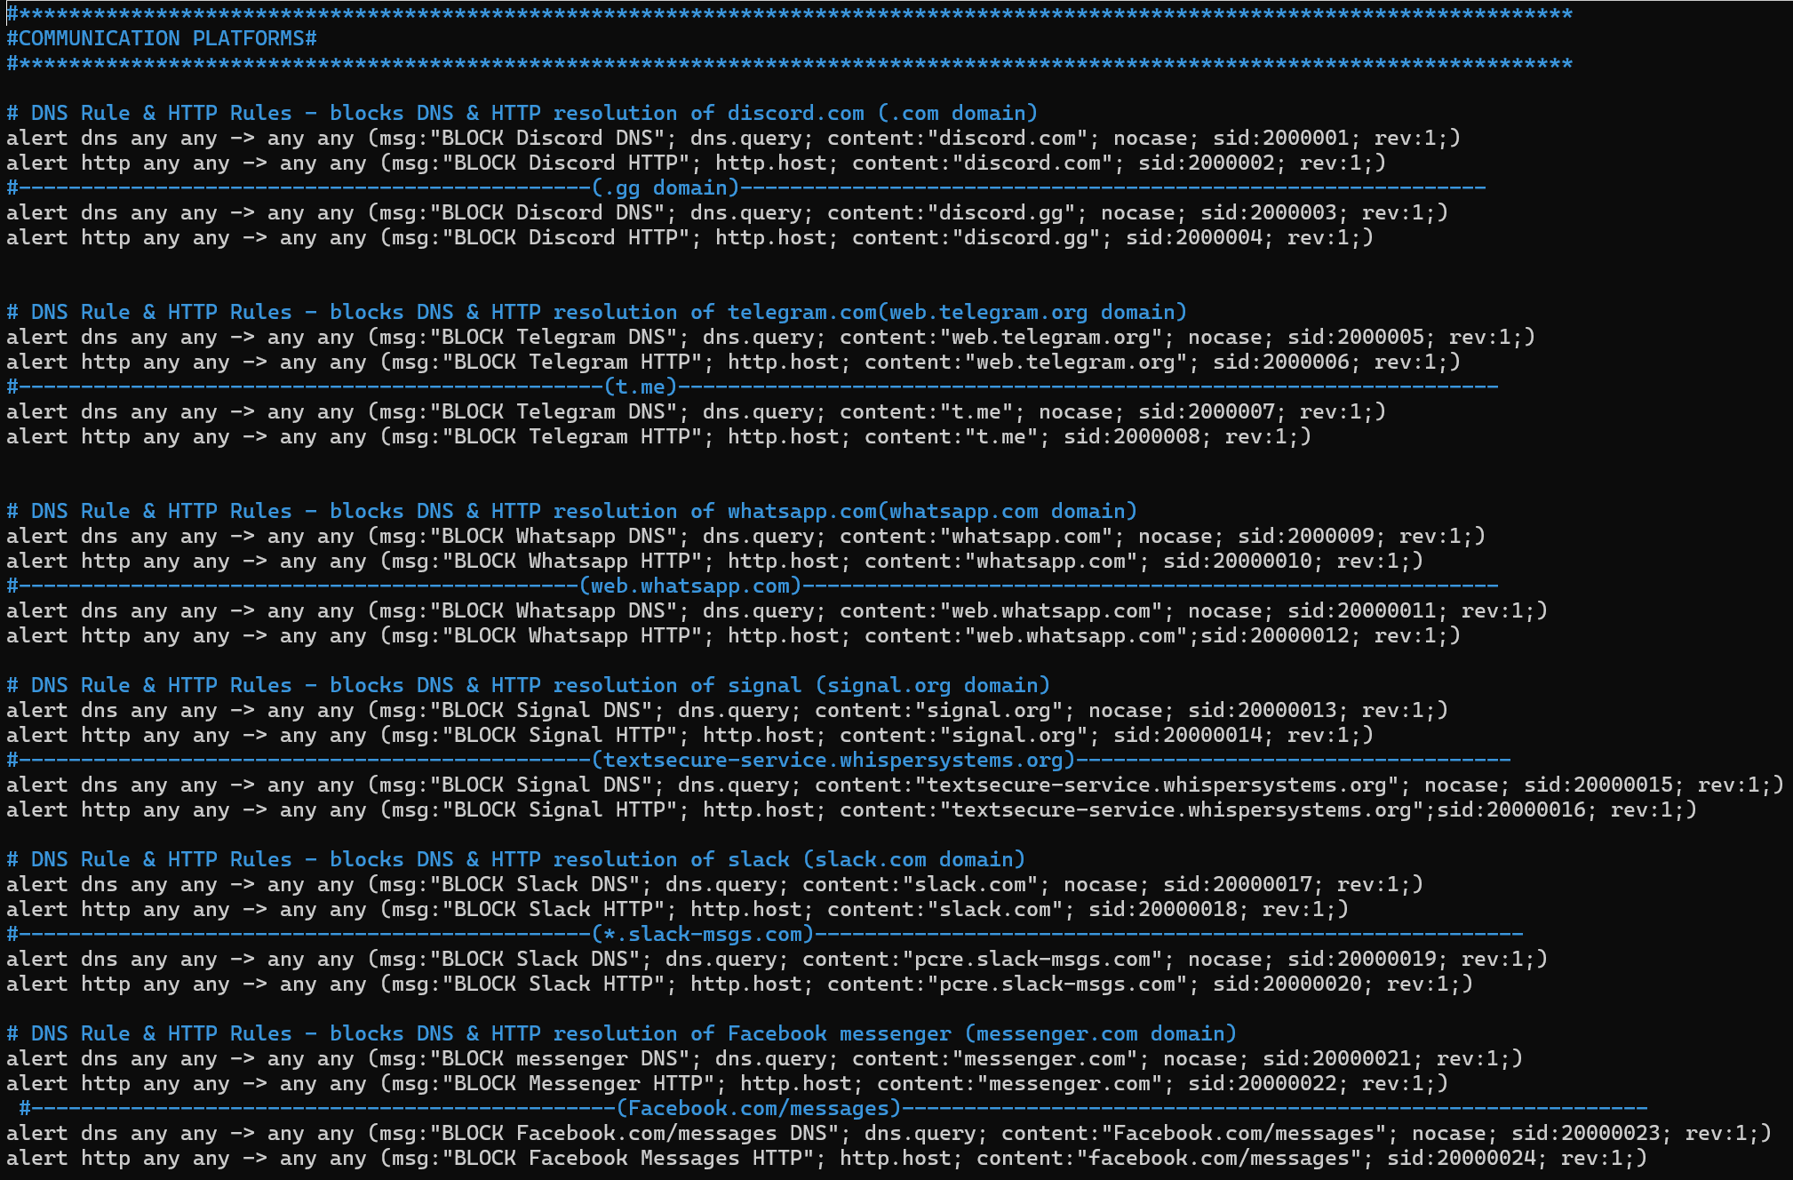

P7: Assist with threat modelling to identify business impacts
How I Connected Threats to Business Impact:
From Dark Web findings:
- Leaked credentials → attackers gain unauthorized access → data breach → $4.45M average cost + reputation damage
From SOC work:
- Undetected malware → data exfiltration → loss of intellectual property → competitive disadvantage
- Ransomware indicators → potential business shutdown → revenue loss
I prioritized mitigations based on severity: patch critical vulnerabilities first, implement MFA, deploy better monitoring.
Evidence: I didn't just find threats—I explained what they actually meant for the business and what needed fixing first.

Using AI in CTF is BLOCKED.

P8: Apply tools and techniques for threat intelligence and modelling
My Dark Web Tools:
- TOR browser for accessing darknet markets
- Spiderfoot and OpenCTI for OSINT collection
- Breach monitoring tools and darknet crawlers
My SOC Tools:
- SIEM platforms (ELK, Splunk, or Wazuh) for log analysis
- IDS/IPS (Snort/Suricata) for signature detection
- Wireshark for packet inspection
- MITRE ATT&CK framework for mapping threats
Evidence: I used industry-standard tools across both intelligence gathering and operational monitoring.
Wazuah: 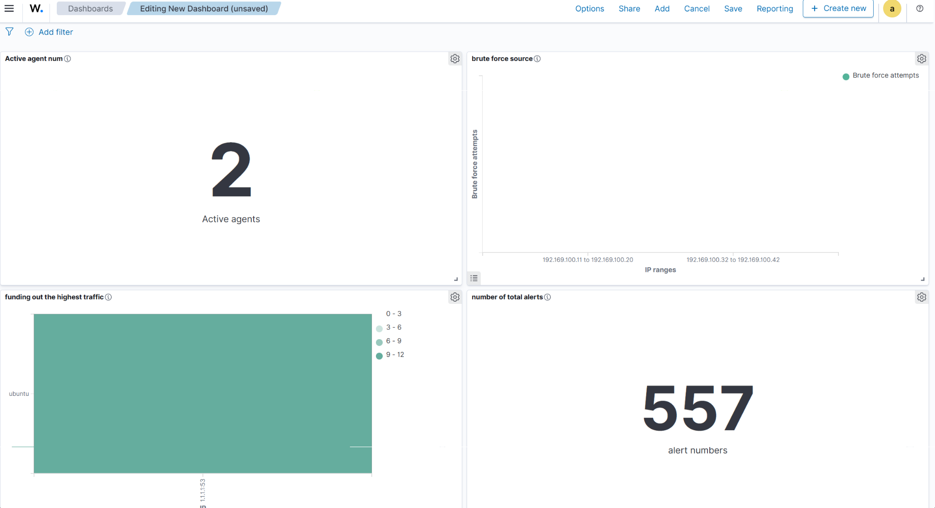

-suricata:
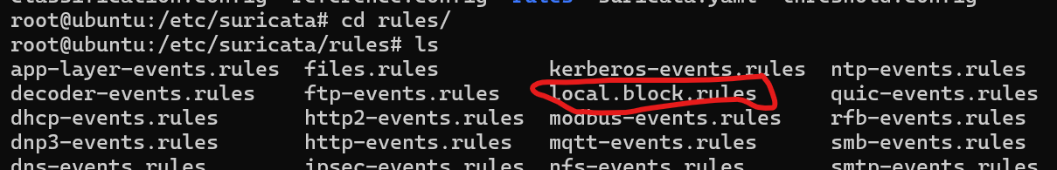
Tor Browser. And python:
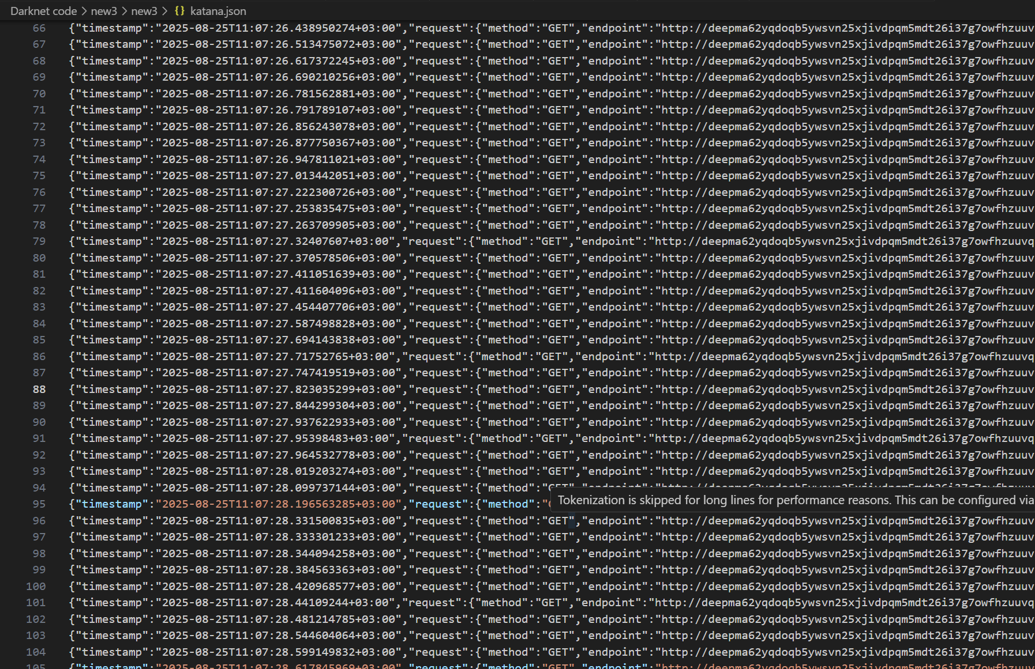
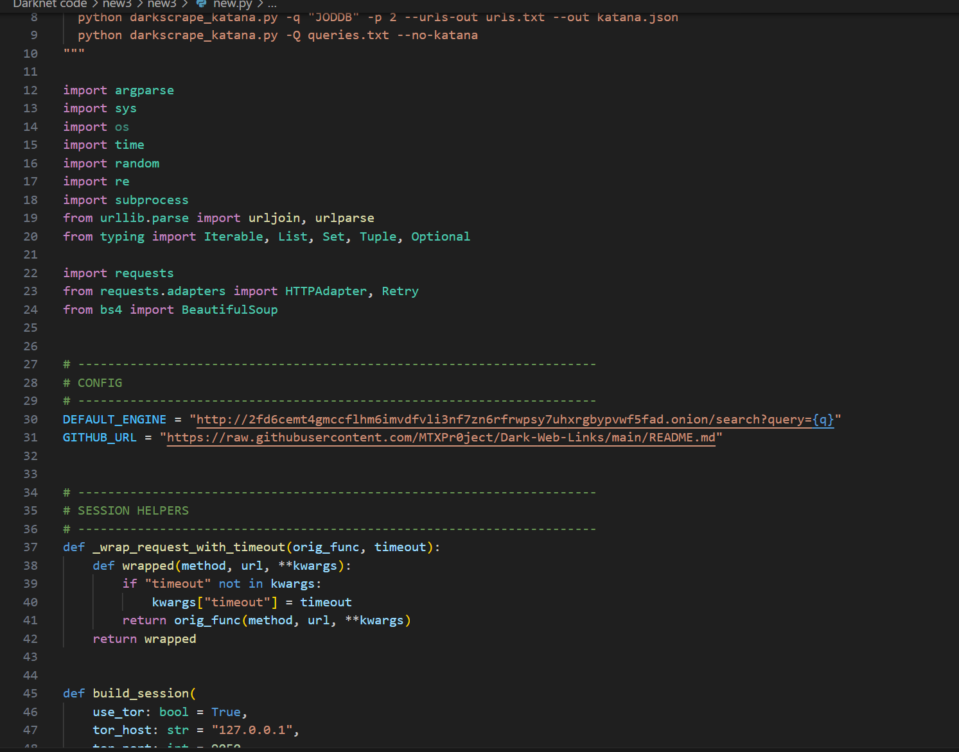
P9: Produce threat intelligence reports and guidance materials
What I Created:
From Dark Web Project:
- Intelligence reports documenting leaked organizational data
- IOC lists (compromised emails, domains, file hashes)
- Risk assessments and mitigation recommendations
From SOC/CTF:
- Incident analysis reports
- Alert triage summaries
- Attack pattern documentation
Evidence: This documentation proves I can produce professional threat intelligence in different formats for different audiences.

P10: Disseminate and communicate threat intelligence
How I Shared My Findings:
Dark Web alerts:
- Immediate notifications when organizational data appeared on dark web
- Clear explanations of what was leaked and what it meant
- Actionable steps for stakeholders (password resets, monitoring)
SOC communications:
- Incident reports during CTF
- Alert escalations to team members
- Summary briefings on attack patterns
Evidence: I communicated technical findings in ways that made sense to different audiences—from technical teams to business stakeholders. (Mentors and manager)
